Name:___________________________________ Date:__________ Score:____/_____
Advanced Placement Statistics
MANDATORY
Summer Assignment 2015
- This assignment reviews some of the basic skills/concepts I would like you to know/understand prior to taking this course.
- This assignment also demonstrates that you are prepared for the workload that comes with an AP course!
- Due Date: FIRST DAY OF SCHOOL!
  - You will lose 10 points for each day this is late.
- To take AP Statistics it is required that you complete this assignment to be turned in on the first day of school!
  - No excuses! Get this done if you want to take this course!
  - This is a first attempt to measure your level of responsibility and commitment to AP Statistics
- This will serve as your first test grade for the course.
- A graphing calculator is required to complete this assignment. Additionally, a graphing calculator is required for this course.
- Be sure to continually check the EHHS AP Stat blog over the summer—here you will find helpful hints, links with resources you can use for its completion, class updates/news, and even potential credit opportunities
- If at any point over the summer you have questions feel free to email me at carofano.fm@easthartford.org. I’m more than willing to help so you can start off with an A!
EHHS AP Statistics Blog: CHECK IT!
http://ehhsapstat.blogspot.com

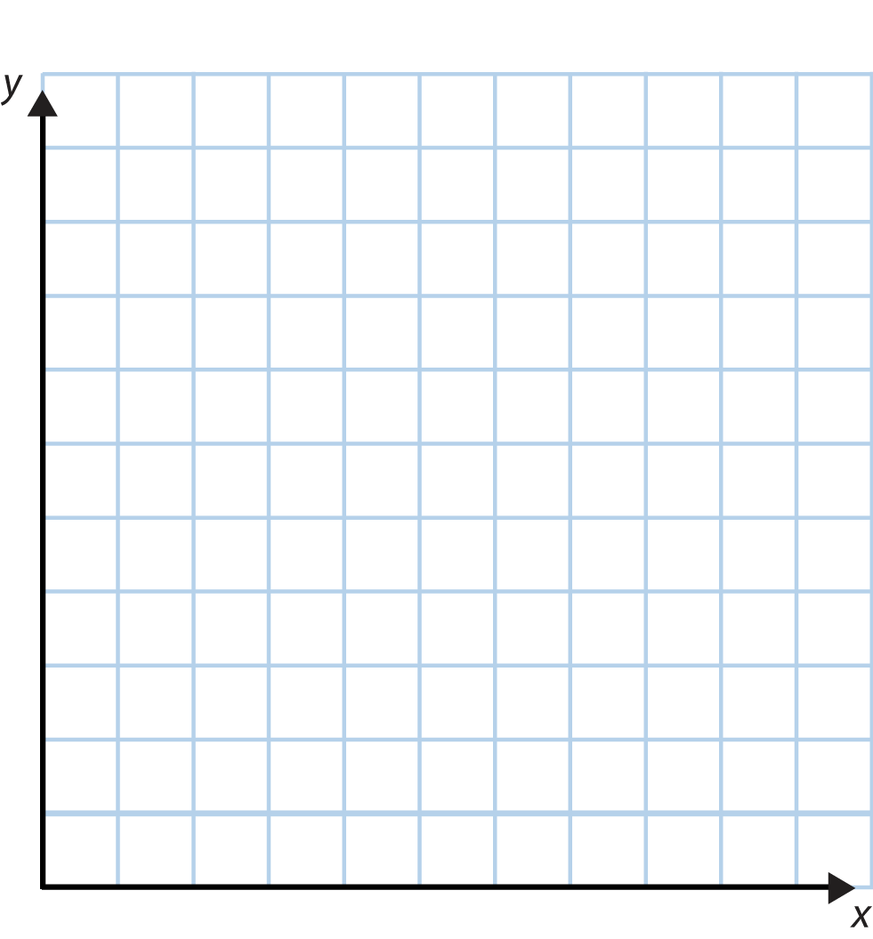
1. Create a scatter plot for the # of hours versus the population of bacteria (in thousands). Be sure to provide all necessary labels and a title. (4 points)
# of Hours | Population of Bacteria (in thousands)
2 | 4.19
5 | 8.46
6 | 9.35
8 | 15.06
9 | 21.98
10 | 29.72

2. The table below shows the score distribution for AP Statistics Exam Scores in May, 2012. Create a bar graph to display this score distribution. Be sure to include all necessary labels and a title. (4 points)
AP Exam Score | # of Students
1 | 10
2 | 9
3 | 15
4 | 24
5 | 7

Use the following information for questions 3-7:
An insurance company is conducting a study in Connecticut of “at risk” drivers—those drivers most likely to be in an accident. The insurance company decides to define each of the following groups as “at risk” drivers:
- Drivers under 21 years of age
- Drivers over 75 years of age
- Drivers of any age with a traffic ticket in the last year.
 | Under 21 | Over 75 | Other Ages (21-75) | Total
Traffic Ticket | 24 | 11 | 218 | 253
No Traffic Tickets | 29 | 84 | 634 | 747
Total | 53 | 95 | 852 | 1000
The insurance company took a random sample of 1,000 Connecticut drivers to determine their age and whether they had received a ticket in the last year. These data are shown below:
*BE SURE TO SHOW ALL WORK FOR EACH PROBLEM BELOW TO RECEIVE FULL CREDIT*
Example: The probability a person is under 21 = $\frac{53}{1000}=.053$
3. What is the probability that a randomly selected driver was over 75? (2 points)

4. What is the probability that a randomly selected driver is considered “at risk?” (3 points)

5. What is the probability that a given driver who is under 21 received a traffic ticket in the past year? (2 points)

6. What is the probability that a randomly selected driver received a traffic ticket in the past year? (2 points)

7. Based on your answers to number 5 and 6, do you think that receiving a traffic ticket and age are independent? That is, does age appear to be related to the likeliness that you receive a ticket? Explain your reasoning. (2 points)

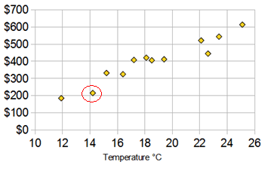
Use the graph shown below to answer questions 8 – 14. The graph shows the predicted ice cream sales ($) based on the temperature (°Celsius) for a given day.
8. What is the (approximate) y-coordinate of the point with the largest x-coordinate? (1 point)

9. What is the (approximate) x-coordinate of the point with the lowest y-coordinate? (1 point)

10. Does the graph shown have a positive or negative association? Circle the appropriate word for each of the bolded options: (2 pts)
There is a positive/negative association between temperature and predicted ice cream sales. Generally, as temperature increases/decreases, predicted ice cream sales increase/decrease.
11. Write the coordinates of the circled point below. (2 points)

12. Interpret the meaning of the coordinate pair for this circled point in a complete sentence (in context!)—what does this point tell us about temperature/ice cream sales? Be detailed! (2 points)

13. For the scatter plot above, what is the explanatory variable (also known as the independent variable)? (1 point)

14. For the scatter plot above, what is the response variable (also known as the dependent variable)? (1 point)

15. Use your graphing calculator to find the linear regression equation (line of best fit), correlation, and coefficient of determination for the data set below. Round to three decimal places. See below for calculator help/instructions. (4 points)
x (# of hours) | 2 | 5 | 6 | 8 | 9 | 10
Y (Population of Bacteria, in thousands) | 4.19 | 8.46 | 9.35 | 15.06 | 21.98 | 29.72

Linear Regression Equation (Line of Best Fit): ______________________________________________________

Correlation (r) = ___________________ Coefficient of Determination ($R^{2}$) = __________________

Helpful Hints:
- If your calculator does not show r and R^2, you need to turn these capabilities on. To do so, press 2nd 0 to go to the Catalog. Then, scroll down to “DiagnosticOn.” Press enter. Then, press enter again and the calculator will say “Done.” Now, if you re-do the LinReg(a + bx), R and R^2 will appear below the equation.

- If you need help remembering how to do this on your calculator, go to the Stat blog. On the right, choose the “Using Your Graphing Calculator” link. Scroll down to #6, Working With Bivariate Data; first, select “Scatterplots” to enter your data, then choose “Linear Regression” for step-by-step instructions for finding the equation.
16. Use the equation calculated above to predict the population of bacteria after 15 hours. Show all of your work in the space below. (2 points)

17. Suppose the actual population of bacteria after 15 hours was 45 thousand. How far off was your prediction? In statistical terms, calculate the residual. (Residual = actual value – predicted value) (2 points)

Use the following data for questions 18 – 20.
The data below shows the scores for 12 students on a recent science pre-test:
83, 80, 63, 79, 83, 77, 66, 80, 73, 90, 77, 15
18. Calculate the mean (average) score on the pre-test, by hand. Show all work in the space below (2 points)

19. Calculate the median score on the pre-test, by hand. Show all work in the space below. (2 points)

20. For this data set, the mean is lower than the median. Why do you think this is the case? (2 points)

21. What is the range (range = max – min) of the data set above? Show your work in the space below. (2 points)

Using Your Graphing Calculator:
22. Follow the steps below to complete the table of summary statistics for the science pre-test data given above. (3 pts)
**These answers for mean and median SHOULD match those above. Double-check the work you did “by hand” to make sure it’s correct!**
- Enter the data in L1. To do so, press STATEDIT
  - To clear L1, highlight the title L1 with your cursor and press CLEARENTER
- Go to the home screen. (Press 2ndMODE to “Quit”)
- Generate the 1 Variable Statistics. To do so, press STATScroll right to CALChighlight 1-Var Stats and press ENTER
- Define where your data is stored. Type L1 after 1-Var Stats. To type L1, press 2nd1.
- The mean and standard deviation can now be seen. Scroll down to see the 5 number summary.

Minimum
First Quartile (Q1)
Median
Third Quartile (Q3)
Maximum
If that wasn’t helpful you can again use the “Using Your Graphing Calculator” link on the blog. You can find these steps under 5. Working With Univariate Data (Making A Table, Clearing Lists, Finding One Variable Statistics)
Mean ($\overline{x}$)
Standard Deviation ($S_{x}$)

